**Annual EDI Report to Board of Trustees June 2023**

**Report from Head of Equality, Diversity & Inclusion Transformation**

This report covers the operation of the CIOB in respect of equality, diversity, and inclusion (EDI) for the period 1 June 2022 to 1 June 2023.

|  |
| --- |
| **Executive Summary** |
| **Completed initiatives:**   * CIOB guidance on inclusive and accessible events published (July 2022) * New EDI Awards added to CIOB Awards (Sept 2022) * First CIOB EDI members survey conducted with high rates (85%) of approval for our approach (September 2022) * Inaugural International D&I conference (Nov 2022) * Launch of CIOB EDI Ambassador role (Nov 2022) * Continued increase in signatories to the D&I Special Report and Charter (165 by May 2023) including Balfour Beatty, Mace, Liang O’Rourke and Kier * Four well attended meetings of the CIOB Employers’ D&I Forum * Engagement with policy makers and politicians on EDI * Progress on EDI Memorandum of Understanding with ICE, LI, RIBA, RICS & RTPI * Representation at senior levels in the sector (e.g. CLC, CIC) to ensure alignment and demonstrate CIOB thought leadership * Engagement with external agencies promoting EDI (e.g. BPIC, Building People) * Representation at external sector events (e.g. UK Construction Week, WoW) * Member engagement on EDI at MF (Sydney), Hub Committees and Regional forums * Marketing & comms output with focus on D&I (e.g. CIOB People) * ‘Promoting female leaders’ initiative lead by Senior Vice President * Hosting series of cross-sector PPE Round-table discussions (from May 2023) * Consultation on new five-year EDI Action Plan (2023/2028)   **Forthcoming activity:**   * Launch of EDI ‘Massive Open On-line Course’ (MOOC) via CIOB Academy (May 2023) * Employment policies & D&I training review d (December 2023) * Collection of broader member data collection (June 2023) * Analysis of detailed member demographics (From December 2023) * Adoption of new five-year EDI Action Plan aligned to Corporate Plan (2023-2028) |

1. **The CIOB’s commitment to Equality, Diversity and Inclusion**

The CIOB’s objectives, defined by our Royal Charter, include the promotion for the public benefit of the science and practice of building and construction. This objective is hard to achieve if we are not sufficiently diverse and, as an industry, we do not reflect society. It is clear that embedding fairness is in everyone’s interest, and recognising that our own journey is just starting, we will work with our members, our networks, other professional bodies and across the wider industry to promote an inclusive and accessible built environment that improves the lives of all.

1. **Roles and Responsibilities**

**i) The Board of Trustees**

As the governing body of the CIOB, the Board of Trustees (BoT) is responsible for the management of the Institute and ensuring that it meets its obligations as set out in the Royal Charter, in addition to relevant legislation and regulations such as the Equality Act (2010). The BoT will consider this annual report to monitor progress against the agreed EDI objectives and other requirements.

**ii) The members’ EDI Advisory Panel**

The CIOB EDI Advisory Panel provides a forum for members with expertise in EDI to promote the agenda across the built environment sector. The Panel works with the CIOB and its Head of EDI Transformation, to better understand the barriers to particular groups and individuals, and to identify opportunities for improvement and innovation within the sector.

**iii) The Head of EDI Transformation**

Established in January 2021, the Head of EDI Transformation role reports to the CEO on a day-to-day basis and to the Board of Trustees annually. The role is responsible for ensuring that the CIOB embeds its commitment to inclusion in all functions and demonstrates leadership across the built environment sector.

1. **Highlighted achievements from the previous 12 months**

**i). The D&I Special Report and Charter[1]**

Launched in November 2021 for all employers in the built environment sector, the Special Report sets out the business case for a commitment to D&I and provides international examples of best practice for organisations to learn from. The accompanying Charter sets out five commitments as a step-by-step guide to embedding and promoting inclusive employment practices. These commitments are purposefully tailorable to any size of organisation and operating environment to facilitate the broadest participation.

By May 2023 165 companies have publicly signed-up to the Charter on the dedicated CIOB webpage sharing their logos with us, including companies based in China, Malta, Canada and UEA as well as across the UK and RoI. The Special Report and Charter continues to generate interest in the CIOB and its position on D&I and has initiated conversations with employers in the sector on membership, as well as other external agencies as set out below.

The new CIOB Employers’ Forum for Diversity & Inclusion was established in 2022 to provide signatories to the Charter with an opportunity to share challenges and successes on their developing approaches in this area. During the reporting period the Forum has held four well attended quarterly meetings (each with 25/35 companies participating) which resulted in referrals to the Business Development Team. The March 2023 meeting heard from a senior representative from Hs2 on their requirements as a major client on their supply chain, providing valuable business insights to engaged companies.

**ii). Inaugural CIOB International EDI Conference**

Opened by CEO Caroline Gumble, the CIOB hosted its first full day EDI Conference on 15 November 2022 with high profile speakers and attendees from around the globe. Circa 110 delegates joined the virtual event to listen to panel discussions on promoting gender equality and promoting inclusive workplace culture. The audience heard from 20 expert speakers discuss a range of topics from the member survey results to ‘*what kind of a tomorrow?*’ do the CIOB Tomorrow’s Leaders want to see. The Conference provided a global platform for discussing the promotion of EDI in the sector and helped to deliver thought leadership on this key agenda.

The CIOB is currently planning a ‘hybrid’ approach for the 2023 EDI Conference on 28 November with a target of 150+ attendees.

**iii). CIOB EDI awards**

September 2022 saw the launch of two new EDI Awards[2] (corporate & individual) to the suite of annual CIOB Awards. The EDI awards were introduced to recognise exceptional commitment to promoting a fair, inclusive and welcoming built environment sector. The first individual award winner was Rebecca Lovelace, CEO of Building People and the company award went to St Modwen. The EDI awards will now be a part of CIOB awards event into the future to encourage best practice and innovation on this key policy area.

**iv). Partnership working with professional membership institutes**

Since spring 2021, the Head of EDI has been liaising with equivalent roles in the CIOB’s sister membership organisations (RICS, RIBA, ICE, RTPI, LI) on shared opportunities and challenges in respect of EDI with the aim of a consistent approach in this area across the built environment. CEOs and Senior Leaders of these institutes recognised the value of partnership working and signed a Memorandum of Understanding[3] committing to working together in April 2022.

The MoU committed the institutes to a three-year SMART action plan published in July 2022[4] setting out 17 activities across three keys areas:

*1). Member data collection and analysis to identify underrepresentation*

*2). Repairing the ‘leaking pipeline’ between education and employment in the industry*

*3). Raising standards of knowledge behaviour and practice in respect of EDI*

The on-going initial activities have included agreeing an approach to member data collection across the professions and developing a survey for engaged employers to understand differentials in employment rates. The MoU has also resulted in joint presentations to sector-wide events (e.g. UKCW and at Plymouth University) to promote partnership working as well as jointly hosted events such as the Pride in Construction event at RICS on 7 June .

**v). Sector leadership**

In parallel with the partnership working with member institutions, the Head of EDI has also been invited to represent the CIOB at the Construction Leadership Council’s Skills Gap & People forum and the Culture working Group, as well as the Construction Industry Council’s EDI Committee steering group. The aim of this engagement is to ensure alignment and consistency across the sector and to avoid duplicated effort. It is also evidence of a recognition of CIOB’s increasing influence on the EDI agenda.

**vi). Engagement with governmental policy makers**

Working with the Policy and Public Affairs Team, the Head of EDI has participated in meetings with key policy makers and politicians. This has included engagement with the

Government officials in Oceania and South Africa as well as Westminster and the devolved parliaments. The Head of EDI and Policy Team colleagues met with Rt Hon Caroline Noakes MP and with Lord Stunell who voiced support for a more welcoming and inclusive construction sector. Meetings were joined with the South African Council for the Project and Construction Management Professions (SACPCMP) in June 2022 and representatives of the Department of Premier and Cabinet in Tasmania (August 2022) who were interested in the CIOB’s commitment to a fair and accessible sector.

**vii). Representation at external events**

The Head of EDI has represented the CIOB and promoted the D&I Charter and CIOB commitment to the agenda at several engaged universities (e.g. Nottingham Trent, Sheffield Hallam, Angela Ruskin and Plymouth University). Other appearances at external events and conferences have included being a panellist at London Expo (Nov 2022), the second annual Black Professional in Construction awards (December 2022) and UKCW (May 2023) as well as a keynote presentation at an employers’ session hosted by Mace on adopting a strategic approach to EDI (May 2023).

**viii). Promoting female leaders’ initiative**

Chaired by the Senior Vice-President, this internal working group aims to identify the common factors that successful women share to identify lessons-learned on how we can promote gender equality in senior levels across the sector. The CIOB hosted a well-attended event in Parliament to welcome a delegation of construction sector women from the US (‘*Building Bridges’*) to highlight the need to improve female representation in the UK sector in June 2022. Members of the working group organised a successful CIOB stall at the ‘*Women of the World*’ event in March 2023 with the aim of speaking to girls and women who had not previously considered construction as a career. In addition, the working group developed a proposal for a series of high-profile cross-sector roundtable events that will focus on the issue of PPE provision for women and other underrepresented groups.

**ix). EDI Advisory Panel**

The (members) EDI Advisory Panel met on a quarterly basis over the last year and significantly contributed to developing the CIOB’s approach to EDI. This was done with regular progress updates on agreed activities, consultation on the CIOB EDI Action Plan and participation in events such as the EDI Conference. Two new Tomorrow’s Leaders representatives were added to the Panel in order to ensure representation across age groups (July 2022) and the Terms of Reference is currently being reviewed to ensure continuity in its membership. The Chair of the Panel has reported to the External Affairs Advisory Board on its activities and its members were instrumental in the development of the EDI Ambassador role.

**x). EDI Ambassador role**

In November 2022 the new CIOB EDI Ambassador Role[5] was launched to recognise the valuable experience and knowledge of EDI in the built environment that members can bring to our discussions on this key policy area. The voluntary role of CIOB EDI Ambassador provides an opportunity for enthusiastic members to ensure EDI is on the agenda at a local level is available to CIOB members with knowledge and enthusiasm a to work with local Hubs and the Tomorrow’s Leaders community to make a positive contribution to the CIOB’s approach. CIOB EDI Ambassadors help disseminate best practice across the CIOB networks and identify areas for action to promote equitable treatment for all.

The proposed EDI Action Plan (2023-2028) includes a target to see EDI Ambassadors appointed in 70% (i.e. 40 Ambassadors) of Hub Committees by December 2025.

**xi). Member engagement**

The Head of EDI has delivered presentations to members at Hub and Regional forums over the last twelve months. This has included sessions in Northampton, Liverpool, Leeds and a joint event with the Northern Ireland Equality Commission and NI CITB in Belfast in November 2022. Also in November 2022, for the first time, a dedicated and popular session on the benefits of EDI in the sector was hosted by the Senior Vice-President at the Members Forum in Sydney.

**xii). EDI Member Survey**

September 2022 saw the launch of the first dedicated EDI members’ survey to understand the support for the CIOB’s commitment to promoting a fair and welcoming sector. The survey was run for a month and was presented in UK English with a translated version for members in China. Responses were received from 3105 members (9%) on this single-issue survey with 85% of members welcoming the CIOB’s commitment to a fairer more representative sector. The overwhelming majority also welcomed CIOB working in partnership with other professional membership organisations and agreed that EDI should be a key component in qualifications and training. The members views have been reflected in the objectives set out in the EDI Action Plan (2023-2028) with the launch of the ‘Massive Open On-line Course’ (MOOC) in June 2023. The survey also revealed significant interest in getting involvedwith CIOB in promoting a more welcoming, fair and representative sector, particularly amongst applicant and student members, female members, younger members, international members and those from ethnic minorities. The launch of the new CIOB EDI Ambassador role (Nov 2022) aimed to harness this enthusiasm.

**xiii). EDI Action Plan continuity**

The CIOB’s first internal EDI Action Plan (2021-2022) was adopted by the Board of Trustees on 25 June 2021. The actions and targets incorporated in the action plan had previously been agreed with Directors and subject to consultation with all members, Trustees and staff during May 2021. The objectives and actions covered all functions of the CIOB from governance to membership and its role an employer. A closing report for this first EDI Action Plan is added as an appendix at page 11 of this Annual Report.

The Head of EDI Transformation, working with the Leadership Team and the EDI Advisory Panel, developed a proposed five-year EDI Action Plan for the 2023-2028 period to align with the new CIOB Corporate Plan. This draft Action Plan was subject to consultation with all members, Trustees and staff during April 2023 with 27 comments and suggestions received. This new EDI Action Plan will be presented to the Board of Trustees for consideration and adoption in June 2023.

Given the duration of the Action Plan, the adopted version will be considered a ‘live’ document to be revised and updated in response to external events and any changes to the regulatory or legislative environment. Regular progress reports on the Action Plan objectives will be given by the Head of EDI to the Leadership Team, EDI Advisory Panel and the Board of Trustees.

1. **Analysis of membership and employee data and a summary of actions that result**

The CIOB recognises the many benefits of having an equitable and inclusive approach in our role as a professional membership institute and as an employer. Having an accurate picture of our membership and our workforce will allow us to identify underrepresentation and measure the impact of policies and practices adopted to promote diversity and inclusion.

**i). Membership profile data (May 2023)**

Currently, the CIOB members personal ‘diversity’ data is limited to age (i.e., DoB), and gender. Both metrics are tracked through the monthly membership dashboard and reported as KPIs to all staff and Committees.

i). **Age**

The most recent data shows that the average age of members to be relatively stable with Applicants and Student Basic members rising slightly and the age of Student Enhanced members falling on a marginal basis. The desired reduction in the average ages of members overall is not in evidence.

ii). **Gender**

The most recent data demonstrates that the gender split for all Student grades has increased to 24.99% female which is ahead of target. Our Applicant gender split has marginally improved, moving from 10.3% in 2021 to 10.35% in May 2023. However, we are behind target on Applicant gender spilt by 0.65%.

**Actions arising from member data:**

An initiative to expand our understanding of our membership demographic (e.g. disability, ethnicity, sexual orientation, and religion or belief) will be launched in June 2023.

Following the IT review, our member database will be enhanced to facilitate the collection and analysis of this broader membership data on an on-going basis. Data collection will be

embedded into the application process and members will be given the facility to update their personal details at their discretion. We will be ensuring consistency on the data collected with other professional membership institutes as set out in the Memorandum of Understanding signed in April 2022.

The figures in respect of membership age and gender will continue to be reported with the aim of reducing the average age and promoting a more gender balanced demographic.

The initiatives set out in the EDI Action Plan (2023-2028) and the those embedded in the Corporate Plan Skills Gap theme include the objectives of promoting gender balance and a reduced age in the CIOB membership overall. The broader work with the membership organisations also includes the aim of ensuring a more reflective built environment sector.

Appropriate annual targets in respect of the age and gender of membership are set out in the Membership section (page 6) of the CIOB EDI Action Plan (2023-2028).

**ii). Employee data**

The personal questions that we ask CIOB employees residing in the UK and Ireland was revised and expanded in 2021 to include the protected characteristics as defined by the UK’s Equality Act (2010). An internal campaign to improve staff disclosure rates was conducted, providing information about why the data is need and giving assurances on confidentiality. The proportion of colleagues who have completed the questionnaire by March 2023 was 88%.

Employees residing in countries outside the UK/Ireland were only asked to provide age, gender, and disability in recognition of the different legislative, regulatory and cultural environments in countries where our employees reside. The proportion of international colleagues who have provided their data lower at 50%.

The following employee data was reported on 31 March 2023:

**AGE:**

2022

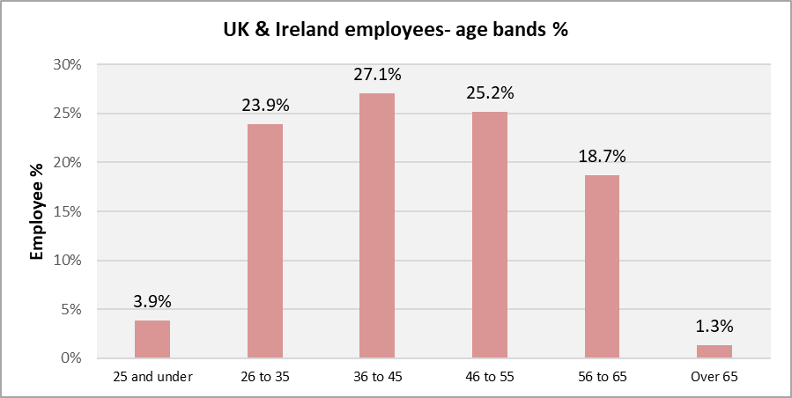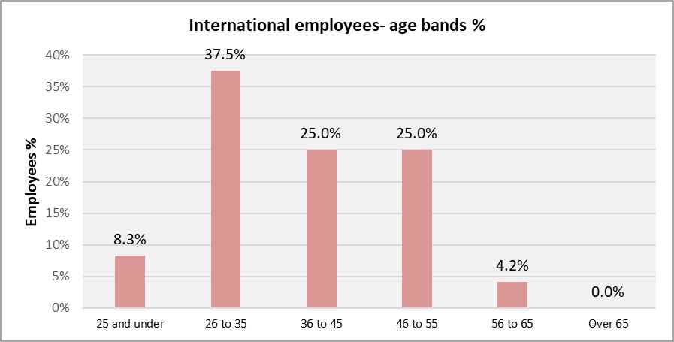

Employee age data continues to demonstrate that the demographic of CIOB’s international colleagues is a narrower but younger cohort, with significantly fewer staff over 56 years of age.

**Disability:** 2022 2023

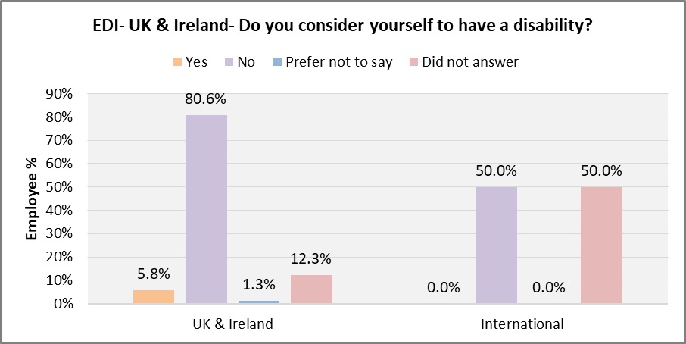

The increased proportion of CIOB staff declaring a disability in the UK and Ireland (5.8%) in 2023 is a positive compared to the wider UK workforce at circa 5%. There has been a welcome and significant increase in the proportion of international and UK based staff demonstrating the confidence to answer the question on disability.

**Gender:**

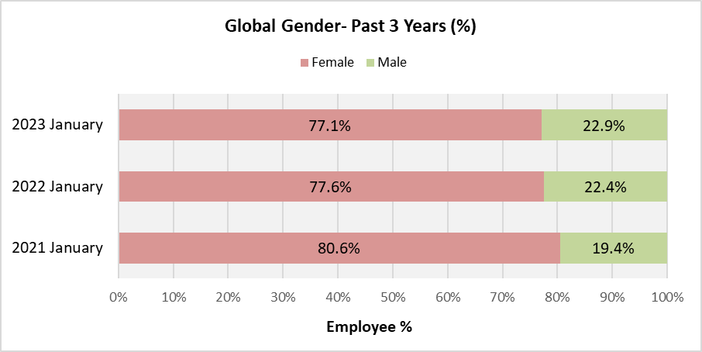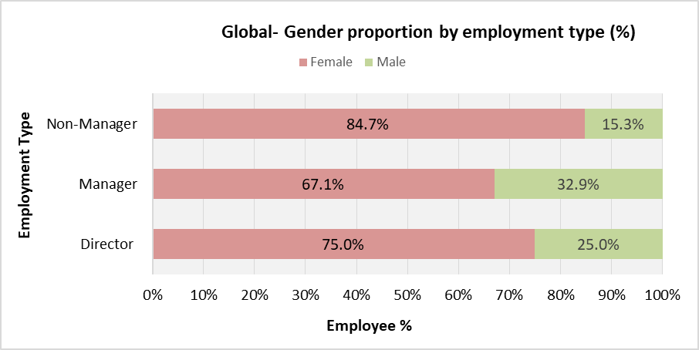

The gender data demonstrates a significant under-representation of male employees. However, the trend over the last three years is positive and this anomaly is reducing year-on-year albeit slowly. Further analysis shows that the gender imbalance is widest in non-managerial roles and at Director level, with the highest representation of men (33%) in Manager roles.

**Ethnicity/race:**

The proportion of CIOB staff in the (UK and RoI) who define themselves as Black, Asian or other minority ethnic (BAME) is relatively low at 12.1% compared to the wider UK population at around 14%. However, it is positive when compared to the ONS Workforce Survey estimate of 6% of construction sector employees identifying as BAME. It is also up from 7.7% in 2022.

The proportion of staff members who opted not to answer this question fell from 19% in 2022 to 12% in 2023.

**Other characteristics:**

The higher proportion of UK/RoI based staff who opted not to answer questions on gender reassignment, religion, sexual orientation, and socio-economic background prevented robust analysis in these areas. Nevertheless, considering the encouraging increase in colleagues prepared to answer questions overall and the fact that these questions are relatively new, it is anticipated that more extensive data will be available in twelve months time.

**Actions arising from employee data:**

Colleagues will continue to be encouraged to complete their personal data questions with an internal campaign to address concerns on confidentiality and the positive reasons for sharing the data. Further analysis of the wider protected characteristics (e.g. religion or belief and sexual orientation, social mobility) will be reported in the 2024 EDI Annual Report when the available data will allow meaningful trend analysis.

Consideration will be given to how to redress the balance on gender in employment, in the non-managerial grades.

Although the CIOB falls outside statutory requirements to produce an annual gender pay gap report due to its size, this data will be made available by December 2023 to facilitate year-on-year analysis. A report will also be produced on the feasibility of producing meaningful pay gap data in respect of race (December 2024) and disability (December 2025) as set out in the new EDI Action Plan (2023-2028).

**CIOB EDI (internal) Action Plan 2021-22: Closing report**

1. **Context**

The CIOB’s first internal EDI Action Plan was adopted by the Board of Trustees on 25 June 2021. The actions and targets incorporated in the action plan had previously been agreed with Directors and subject to consultation with all members, Trustees and staff during May 2021. This paper is the final report on progress against the agreed targets at the end of this period. The following five-year EDI Action Plan (2023-2028) will be presented to Trustees at the Members Forum in June 2023.

1. **Key actions successfully completed include:**

* EDI Action Plan adopted by BoT on 24/06/21 (action 1.1)
* EDI training delivered to Trustees & LT (1.3)
* BoT to consider an annual report on progress against EDI action plan (1.6)
* Establish CIOB EDI awards as part of updated and successfully relaunched CIOB Awards (1.9)
* Raising awareness of EDI issues in CIOB Hubs & Regional Committees (EDI Ambassador Role Launched) (2.4 & 2.6)
* Tomorrow’s Leader’s representatives appointed to member’s EDI Advisory Panel (2.7)
* EDI Special Report & Charter launched to encourage corporate engagement (2.8)
* New brand guidance published with evidence of accessibility/inclusion (e.g. minimum font/diverse image library) (5.1)
* New Guidance on inclusive and accessible events launched (5.2)
* Delivery of Academy EDI webinar/video + circulated to local Hub Cttees at suggestion of Trustee (6.2)
* Internal campaign to improve staff data disclosure rates (7.1)

1. **The following key actions are on-going:**

* Embed EDI into the CIOB corporate values (1.4)
* Personal data from Trustees collected and analysed to facilitate identification of trends. (1.5)
* Collection, analysis of updated personal data questions for members delayed due to Tech Review. New target of March 2023 (2.1 – 2.3)
* Review of EDI training options for staff (7.5)

Detailed Action Plan 2021-22 – Closing summary

|  |  |  |  |  |  |  |
| --- | --- | --- | --- | --- | --- | --- |
| 1. **LEADERSHIP & GOVERNANCE** | | | | | | |
| **Objective** | **Actions** | **Resource** | **Responsible Director** | **Measurable Outcome** | **Target** | **Comment** |
| Provide visible leadership by promoting diversity and the benefits of inclusive practices across the construction sector | 1.1 Publish and embed an EDI Action plan for 2021-2022 | Head of EDI | CEO | Adopt and publish new EDI Action Plan: ‘*Laying the foundations*’ to align with period of Corporate Plan 2019-2022. To be publicly available via website. | Action plan adopted June 2021 | Action completed.  EDI Action Plan adopted by BoT on 24/06/21. |
| 1.2 Identify and agree ambitious EDI objectives for the 2030 Vision | Head of EDI | CEO | Consult on and adopt objectives for 2030 with three main areas of focus for an EDI ‘*Road-Map*’: | by December 2021 | Completed.  The 2030 Vision working group delivered a set of ambitious objectives fed into the Corp Plan. |
| 1.3 Ensure BoT awareness of legal requirements and the benefits of commitment to EDI | Time on Board agenda/Head of EDI | Director of Governance | 1. Initial EDI training delivered to all Trustees 2. EDI training added to induction requirements | October 2021  June 2022 | Completed.  Trustee EDI training delivered 28/09/21 |
| 1.4 Embed EDI into the CIOB corporate values | HR Team /Head of EDI capacity | COO | Review the CIOB Values and include commitment to EDI as a key behaviour | December 2022 | Not completed.  Review of Values will be aligned to work on Organisation Design and Competency Development planned Q1-Q2 2023 |
| 1.5 Board of Trustees (BoT) to adopt measures to enhance the diversity of its membership | Director of Governance | Director of Governance | 1. EDI questions to be added to recruitment procedure for BoT and other formal committees 2. Personal data from Trustees collected and analysed to facilitate identification of trends. | December 2021  June 2022 | Completed. Noms Cttee has incorp EDI questions into Trustee recruitment process.  Action on-going.  Conditional on member data collection (action 2.1) |
| 1.6 BoT to consider an annual report on progress against EDI action plan | Time on Board agenda/Head of EDI | Director of Governance | Annual EDI produced by Head of EDI report presented to BoT for agreement | Annually from June 2022 | Completed.  Annual EDI Report to be considered by BoT  Last presented July 2022 |
| 1.7 Require all members representing the CIOB to adhere to our commitment to EDI | Head of Governance | Head of Governance | Add requirement to Code of Conduct for CIOB members representing the organisation. | June 2021 | Completed.  DoG confirms that Rules & Regs state that members will treat others with respect, fairness and equality at all times |
| 1.8 Demonstrate transparency & equity in the CIOB Disciplinary process | Head of Governance | Head of Governance | 1. Analyse data of those subject to process to identify any anomalies 2. Provide training for panel members (e.g. unconscious bias workshops) 3. A commitment to ensure balance on any panels as far as is possible | Dec. 2022  Sept. 2022  June 2021 | Action on-going. Conditional on member data collection (action 2.1)  Completed. Training to take place annually  Completed. Commitment given by Dir of Gov. |
| 1.9 Establish CIOB EDI Awards | Comms Team/  Governance Directorate/  Head of EDI | Head of Governance | Establish CIOB annual awards for contributions to promoting EDI for individuals and companies within the sector | Individual award by end 2022. Co. award by end 2023 | Completed.  EDI Awards presented Sept 2022  as part of updated and successfully relaunched CIOB Awards |
| **2. MEMBERSHIP** | | | | | | |
| **Objectives** | **Actions** | **Resource** | **Responsible Director** | **Measurable Outcome** | **Target** | **Comment** |
| Learn from our increasingly diverse global membership | 2.1 Update Customer Relationship Management (CRM) system to facilitate collection of required personal data | CRM Team/Head of EDI | Director of Corporate Services | Updated personal data questions incorporated in CRM  To include accessibility requirements  *Conditional on GDPR requirements being satisfied* | December 2021 | Action on-going Target not achievable due to Technology Review.  Survey to collect EDI data scheduled for March 2023. |
| 2.2 Comms campaign to encourage members to provide their personal profile data | Membership Directorate/  CRM Team/Head of EDI | Director of Membership | Launch campaign to encourage members to update personal data  *Conditional on GDPR requirements being satisfied* | April 2022 | Action on-going. Target impacted by delay to action 2.1 above |
| 2.3 Collect and analyse membership data to identify anomalies and actions to address them | CRM Team/Membership Directorate  /Head of EDI | Director of Corporate Services | Published analysis of membership demographics to include EDI data to inform approach to a more diverse membership | December 2022 | Action on-going . Target impacted by delay to action 2.1 above |
| Promote EDI at a local level and with Tomorrow’s Leaders | 2.4 Raising awareness of EDI issues in CIOB Hubs | Membership  Directorate | Director of Membership | EDI (e-learning) training made available to Hub Cttees (UK & globally) sensitive to local issues | January 2022 | Completed. EDI webinar circulated to Hub committees Oct 2021 |
| 2.5 Promote greater diversity in Hub Committees | Membership  Directorate | Director of Governance | Revised Hub Committee recruitment process built into ToRs to promote diverse membership | June 2021 | Completed.  Wording agreed for MSEC comms to promote a diverse membership |
| 2.6 Ensure membership participation in EDI via Regional Committees | Head of EDI | Director of Membership | EDI Reps from regional committees on CIOB EDI Advisory Panel | December 2021 | Completed.  New reps joined panel Oct 2021 |
| 2.7 Engage with younger members on EDI | Membership Directorate/  Head of EDI | Director of Membership | Tomorrow’s Leader’s participation in EDI Advisory Panel | December 2021 | Completed.  Two TLs nominated to EDI Advisory Panel Oct 2021 |
| Work in partnership with company members to develop their commitment to EDI | 2.8 CIOB EDI activity to encourage corporate membership | Head of EDI/Director of Governance/  Marketing Team | CEO | Establish a CIOB EDI Special Report & Charter | October 2021 | Action completed. Charter adopted. Public launch 25 November 2021.  148 signatories at Feb 2023. |
| 1. **EDUCATION** | | | | | | |
| **Objective** | **Actions** | **Resource** | **Responsible Director** | **Measurable Outcome** | **Target** | **Comment** |
| Embed EDI into CIOB education and standards | 3.1 Review of Professional Interview process to promote an inclusive approach | Education & Standards Team | Director of Education & Standards | 1. Data collection 2. Training of assessors as element of annual standardisation 3. Standardisation of the interview questions and approach 4. Changes to code of conduct for assessors/verifiers/exam markers | December 2021 | Completed.  Reasonable adjustments & special considerations collected.  ED&I is mandatory training for all interviewers. PR audit in place with due consideration given. Assessor guidance updated accordingly. |
| 3.2 Embed best practice into Fellowship accreditation | Education & Standards Team | Director of Education & Standards | 1. Training of assessors as element of annual standardisation 2. Standardisation of the interview questions and approach 3. Changes to code of conduct for assessors/verifiers/exam markers   4. New EDI content in Leadership standards | September 2021 | Partially completed.  All assessors have had ED&I training as well as Dyslexia and neurodiversity training. Further review in 2023. |
| 3.3 Review & update Member Standards (professional based) | Education & Standards Team | Director of Education & Standards | 1. Add EDI element to member standards learning outcomes assessment 2. Add EDI element as a management competency | October 2022 | Completed.  Within managers competencies. All assessments now anonymous to remove potential bias. |
| 3.4 Adopt EDI element into Standards for HE Framework (academic route) | Education & Standards Team | Director of Education & Standards | Update EDI element with inclusive design (e.g. accessibility/signage) | December 2022 | Completed.  An entire explicit theme is core part of academic professional review. |
| **4. POLICY** | | | | | | |
| **Objective** | **Actions** | **Resource** | **Responsible Director** | **Measurable Outcome** | **Target** | **Comment** |
| Work with construction sector champions to demonstrate thought leadership on EDI policy issues | 4.1 Review EDI Policy position | Policy Team/Head of EDI | Director of Policy, External Affairs and Research | Revised EDI Policy position adopted and publicised on CIOB website | Oct 2021 | Action completed in July 2021 |
| 4.2 Embedding considerations of EDI into all policy review & development | Policy Team/Head of EDI | Director of Policy, External Affairs and Research | EDI as standard element in review/development process | Dec 2021 | Action completed |
| 4.3 Renewed role and support for EDI Advisory Panel with updated ToR and support from Head of EDI | Head of EDI | CEO | 1. Updated ToR adopted 2. Regularly scheduled meetings of Advisory panel at least 4x per annum 3. Advisory Panel positive feedback to CEO & Policy Board | June 2021  December 2022  June 2022 | Completed. ToR agreed by Advisory Panel  Meetings scheduled  Feedback given to EAAB |
| 4.4 Research on workforce diversity in the BE sector to inform our EDI activity | Policy Team | Director of Policy, External Affairs and Research | 1. Research published | October 2021 | Action on-going  Action inhibited by lack of external sector data (e.g. from ONS) |
| **5. MARKETING & DIGITAL** | | | | | | |
| **Objective** | **Action** | **Resources** | **Responsible Director** | **Measurable outcome** | **Target** | **Comment** |
| Adopt an inclusive approach to marketing, communications and engagement activities that promotes the CIOB as welcoming to all | 5.1 Include EDI considerations into new visual brand guidelines | Marketing Team/Head of EDI | Director of Marketing & Digital | New brand guidance published with evidence of accessibility/inclusion (e.g. minimum font/diverse people in image library) | June 2021 | Action completed |
| 5.2 Ensure our events and conferences make all potential attendees feel welcome and valued | Marketing Team/Head of EDI | Director of Marketing & Digital | Develop and adopt guidance on inclusive and accessible events to ensure a consistent approach across the CIOB (i.e. international committees, Hubs, Future Leaders, the Academy etc) | September 2021 | Completed.  Guidance published May 2022 |
| 5.3 Provide members with an opportunity to comment on accessibility & inclusion | Marketing Team/Head of EDI | Director of Marketing & Digital | 1. EDI questions added to standard member survey 2. Stand-alone survey to inform 2030 vision | April 2022  October 2022 | Completed  Completed with positive feedback received |
| 5.4. Promote the CIOB’s commitment with an annual EDI event | Marketing Team/Head of EDI | Director of Marketing & Digital | Launch the first annual CIOB EDI event | October 2022 | Completed. Successful EDI conference held Nov. 2022 |
| 5.5 Ensure the CIOB’s digital offer is accessible | Marketing Team/Head of EDI | Director of Marketing & Digital | Build EDI requirements into Digital Strategy. Review main website and intranet for accessibility. | October 2022 | Completed.  AA accessibility rating received. |
| **6. THE ACADEMY** | | | | | | |
| **Objective** | **Actions** | **Resource** | **Responsible Director** | **Measurable Outcome** | **Target** | **Comment** |
| Provide construction managers with the tools they need to understand and embed inclusive practices | 6.1 Develop EDI resources for Academy Portfolio | Academy Team | Assoc. Director Academy | Launch EDI Technical Information Sheet for both members and non-members | October 2022 | Action on-going . Paused until sufficient best practice is available in the sector. |
| 6.2 Provide globally relevant and accessible resource | Knowledge Hub Team/Head of EDI | Assoc. Director Academy | Launch EDI Webinar aimed at all members on a global basis | August 2021 | Completed. Webinar content delivered by Head of EDI and also circulated to all UK Hub Cttes |
| 6.3 Work with Policy team | Academy Team | Assoc. Director Academy | Launch an EDI Massive Open Online Course (MOOC) with global availability | December 2022 | Partially completed. Launched delayed until Feb 2023 |
| 6.4 Update Code of Practice embedding EDI considerations | Academy Team | Assoc. Director Academy | Add EDI to Project Management Code of Practice for members | January 2022 | Completed.  DI is part of one of the core themes (collaboration) that guide the book. |
| **7. OUR ROLE AS AN EMPLOYER** | | | | | | |
| **Objective** | **Action** | **Resource** | **Responsible Director** | **Measurable outcome** | **Target** | **Comment** |
| Embed a workplace culture that empowers all employees to achieve their full potential | 7.1 Collection and comparative analysis of recruitment and staff data | HR Team capacity | COO | Update of system fields to accommodate all protected characteristics  Internal campaign to improve staff disclosure rates to include reassurance on confidentiality and clarification on what the data will be used for  80% of staff providing an answer to all protected characteristics questions | July 2021  Sept 2021  Dec 2022 | Completed.  Fields successfully updated  Completed  Results from campaign 81.5% for UK and 72% for international |
| 7.2 Annual workforce report to identify areas for action | HR Team (data)/Head of EDI capacity | COO | Annual report to BoT to include workforce profile data with trend analysis and comparators | Annually | Completed.  BoT to consider EDI report each June/July |
| 7.3 Review recruitment and promotion procedures to identify anomalies and agree actions | HR Team capacity | COO | Revised recruitment policy adopted to include guidance on content of ads, anonymous shortlisting, panel make-up & training, mandatory questions on previous experience of promoting EDI | Dec 2021 | Partially completed. Guidance on content of adverts has been reviewed and adopted, questions re current salary have been removed from application process. Anonymous shortlisting adopted where possible and will be considered with implementation of new ATS (to be explored in 2023).  Mandatory questions and panel training will be considered in 2023. |
| 7.4 Equality Impact Assessment of employee policies | HR Team capacity | COO | EIAs are an integral part of the policy review process. Polices reviewed, evidence of EIAs completed and actions agreed. | April 2022 | Partially completed.  Commenced EIA reviews of policies in Q4 2022 – e.g. Personal Relationships Policy. Roll out of policy updates planned for 2023 will include EIA assessments. |
| 7.5 A review of EDI training for staff | HR Team capacity/Head of EDI | COO | Review of EDI options with new materials on offer, informed by best practice and benchmarking. EDI as a mandatory element of induction.  e.g. EDI in the workplace, Unconscious Bias, Managing diverse teams | June 2022 | Action on-going  quarterly internal EDI sessions for new starters – to be planned in 2023 based on capacity and recorded to make best use of time.  Programme of people management training to be delivered Q3 and Q4 2023 and we will note EDI as a requirement within this.  To consider this as a potential Take a Break and Learn topic for 2023 – internal session. |
|  | 7.6 Renew the HR Team’s visible commitment to embedding EDI | Head of EDI | COO | Review and publish an updated HR EDI Statement of Commitment for external audiences | June 2021 | Completed but publication delayed Document reviewed and awaiting publication. This is dependant on completing actions above |
|  | 7.7 Visible commitment to accessibility in the workplace | HR Team capacity/Head of EDI | COO | Review & renew Reasonable Adjustment Policy  Submit application for Disability Confident accreditation | December 2021  December 2022 | Action on-going  We are in the process of investigating the application process required. Target of Q2 2023 to balance planned workload. |
| **8. FINANCE** | | | | | | |
| **Objective** | **Action** | **Resources** | **Responsible Director** | **Measurable outcome** | **Target** | **Comment** |
| Promote equality, diversity and inclusion through a socially responsible approach to procurement | 8.1 Adopt a Responsible Procurement Policy with EDI requirements | Finance Team staff capacity | Finance Director | 1. Expect suppliers to align with our commitment to diversity and inclusion 2. Systematically consider working with SME’s that are led by under-represented groups | December 2021  December 2022 | Completed  Completed |

1. <https://d8.ciob.org/specialreport/charter/diversityandinclusion>
2. <https://awards.ciob.org/equality-diversity-inclusion/>
3. <https://www.ciob.org/news/sector-bodies-unite-to-improve-EDI>
4. [three-year-action-plan-to-improve-equity-diversity-and-inclusion](https://www.ciob.org/news/built-environment-bodies-commit-to-three-year-action-plan-to-improve-equity-diversity-and-inclusion)
5. <https://www.ciob.org/industry/politics-government/campaigns/equality-diversity-inclusion>